Contents

What Drives the Price of a Car? 2

Business understanding: 2

Notebook path: 2

Observations: 2

Initial Observations 2

Cleaned Dataset Summary 3

Key Findings from Visualizations 5

Correlation matrix: 18

Key Business Insights 27

Model Comparison for Price Prediction 28

Summary of Model Performance 29

Summary of Key Business Actions 30

# What Drives the Price of a Car?

## Business understanding:

The business problem revolves around predicting the price of used vehicles based on various attributes such as their age, mileage (odometer readings), engine size (cylinders), manufacturer, condition, and other relevant features.

## Notebook path:

[Practical_Application_2/Shikha_Practical_Application2.ipynb at main · shikhakala/Practical_Application_2](https://github.com/shikhakala/Practical_Application_2/blob/main/Shikha_Practical_Application2.ipynb)

## Observations:

### Initial Observations

#### Dataset Size:

* + Total Records: **426,880**
  + Total Columns: **18**

#### Key Features:

* + **Numerical Columns**: price, year, odometer
  + **Categorical Columns**: manufacturer, model, condition, fuel, drive, type, paint_color, state
  + **Missing Data**: Several columns have significant missing values, particularly condition, cylinders, drive, and size.

#### Key Descriptive Stats:

* + **Price**:
    - Mean: $75,199 (likely includes extreme values).
    - Median: $13,950 (indicating skewed data with outliers).
    - Minimum: $0 (invalid or misrecorded).
    - Maximum: $3.7 billion (likely erroneous).
  + **Year**:
    - Range: 1900 to 2022.
    - Median: 2013.
  + **Odometer**:
    - Median mileage: 85,548 miles.
    - Maximum: 10 million miles (potential outlier).

Data handling to clean the data:

* convert cylinders data type to float and replace data
* drop rows having NULL values less than 5%, 37,276 rows are dropped due to missing data
* convert data type of year column to int
* drop rows having price =0, 28,576 rows are dropped
* drop id, VIN and region columns, 105,203 records are removed as duplicates after dropping id, VIN and region column

### Cleaned Dataset Summary

#### Data Size After Cleaning:

* 1. Total Records: **255,825**
  2. Total columns: **16**

#### Key Insights:

* 1. **Price**:
     + Mean: $16,552
     + Median: $13,888
     + Minimum: $1
     + Maximum: $52,778
  2. **Odometer**:
     + Mean: 97,541 miles
     + Median: 94,648 miles.
  3. **Year**:
     + Median: 2013, suggesting most vehicles are relatively recent.

#### Missing Values:

* 1. Significant missing data in condition (37%), cylinders (41%), and size (72%).

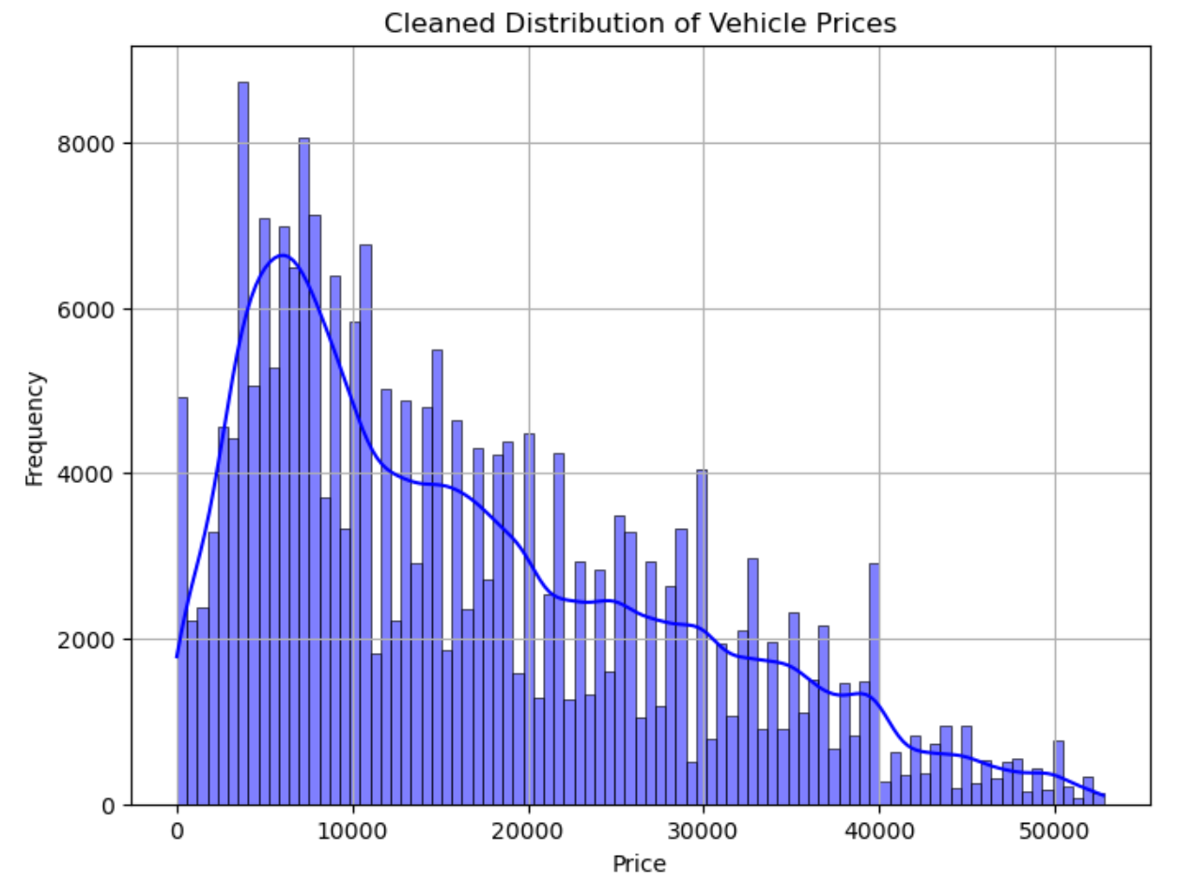

### Key Findings from Visualizations

#### Price vs Year:

* + Newer vehicles (manufactured after 2015) generally have higher prices.
  + Prices decrease significantly for vehicles older than 2010.

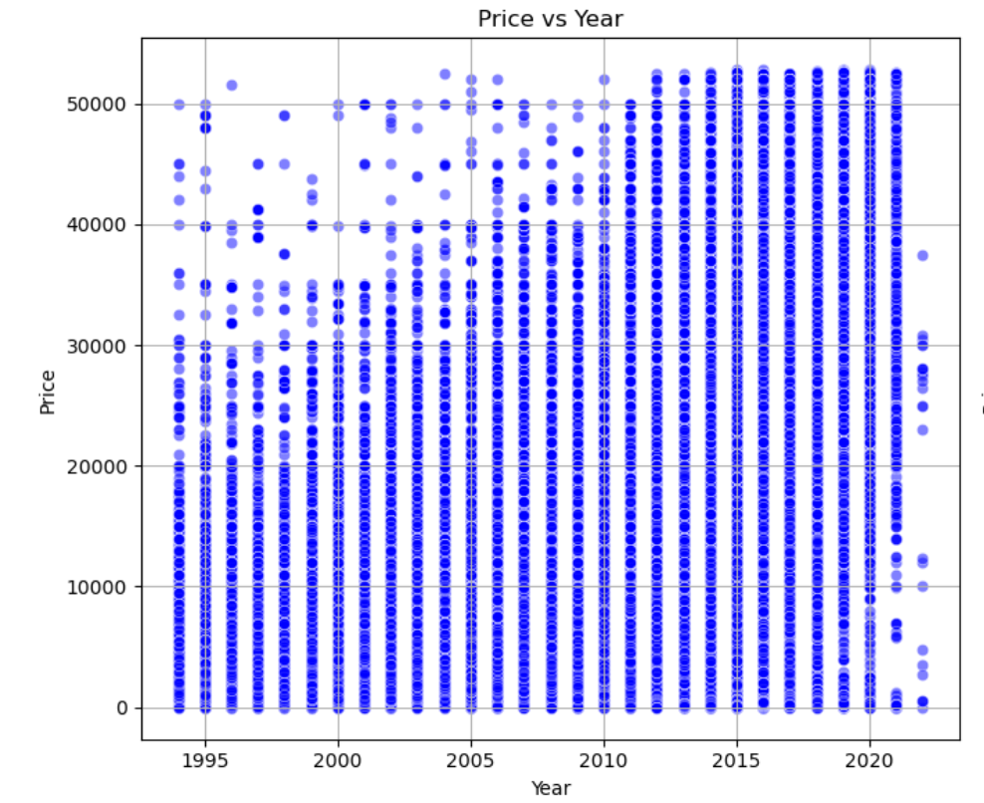

#### Price vs Odometer:

* + Vehicles with lower mileage (odometer < 50,000) tend to have higher prices.
  + High mileage vehicles (>150,000 miles) are priced much lower.

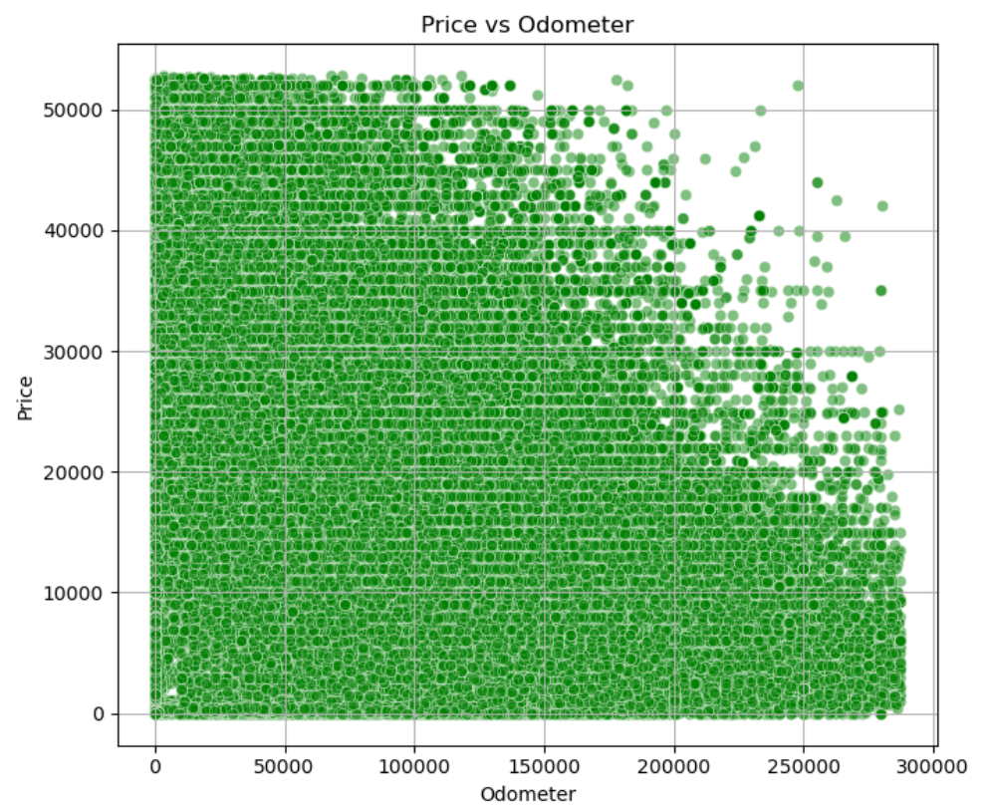

#### Price vs Cylinder:

* + Cars with 4, 6 and 8 cylinders generally have higher prices.

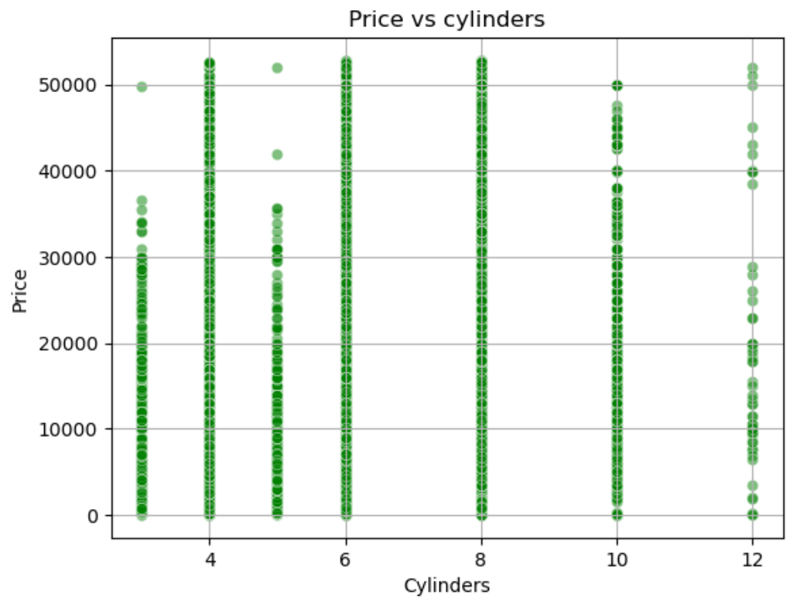

#### Price vs Paint color:

* + Cars in white and black colors generally have higher prices
  + Cars in green and purple are priced much lower.

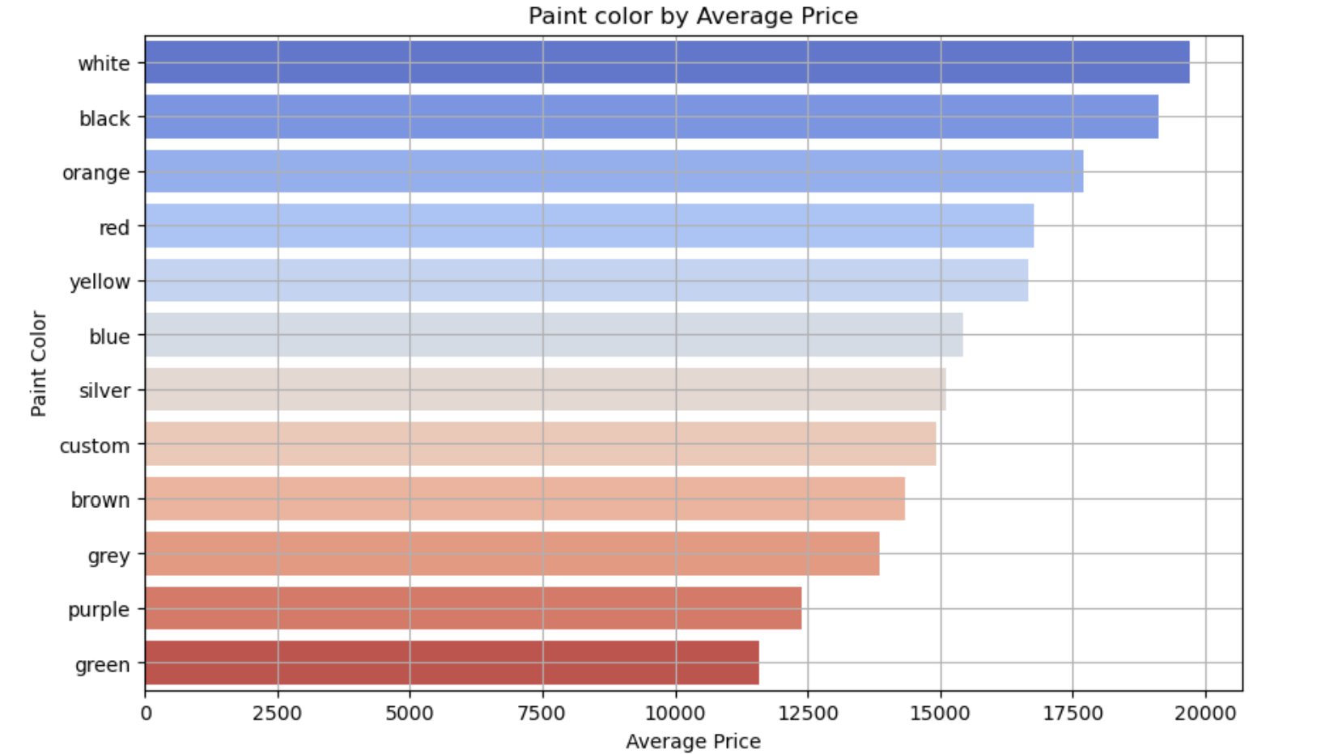

#### Price by Condition:

* + Vehicles listed in "new" and “good” condition have the highest median prices.
  + Vehicles in "fair" or "salvage" condition are priced significantly lower.

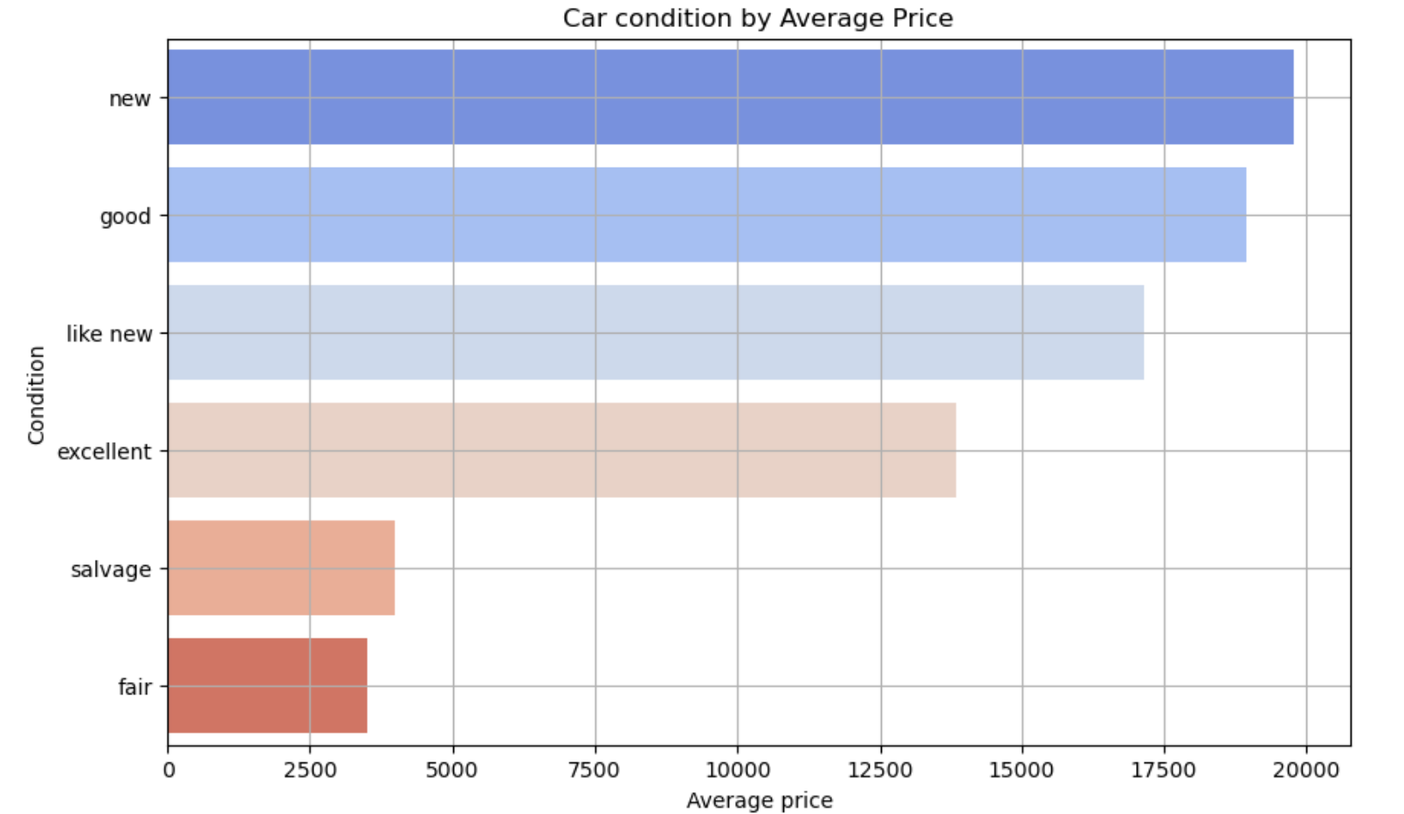

#### Top Manufacturers by Average Price:

* + Manufacturers like **Tesla**, **Porsche**, and **Aston martin, Mercedes-benz, bmw, rover** dominate the higher price range.
  + Brands like **Honda and Chrysler** have lower average prices.

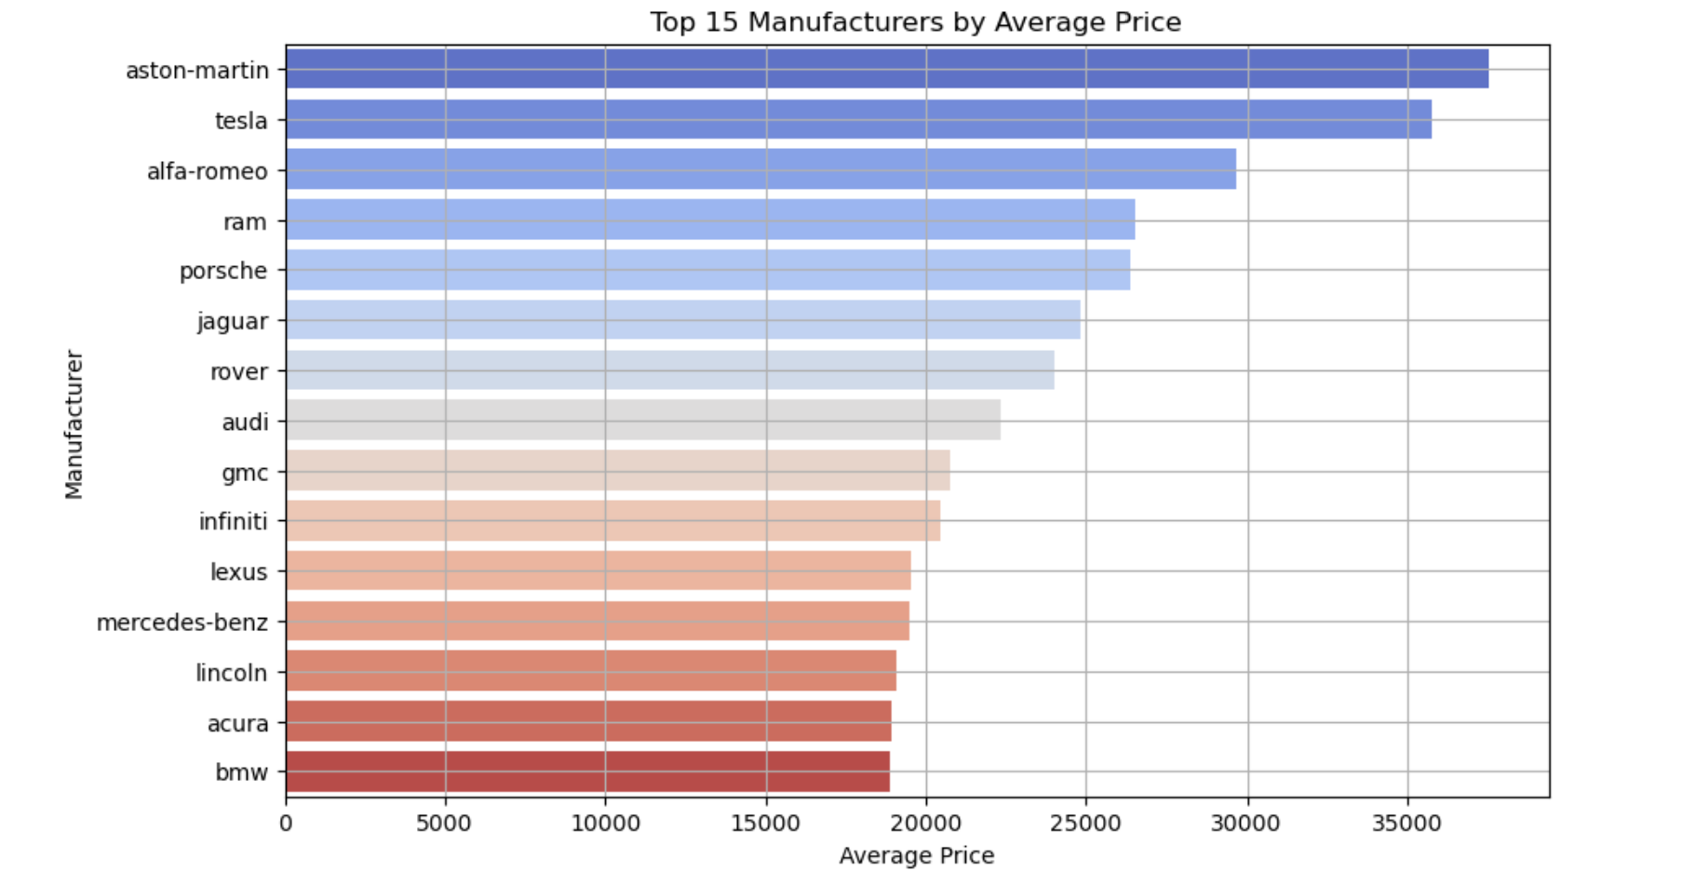

#### Transmission by Average Price:

* + Vehicles with an **"other"** transmission type have the **highest average price**, suggesting they may include specialty or premium vehicles.
  + **Manual** transmission vehicles have the lowest average price

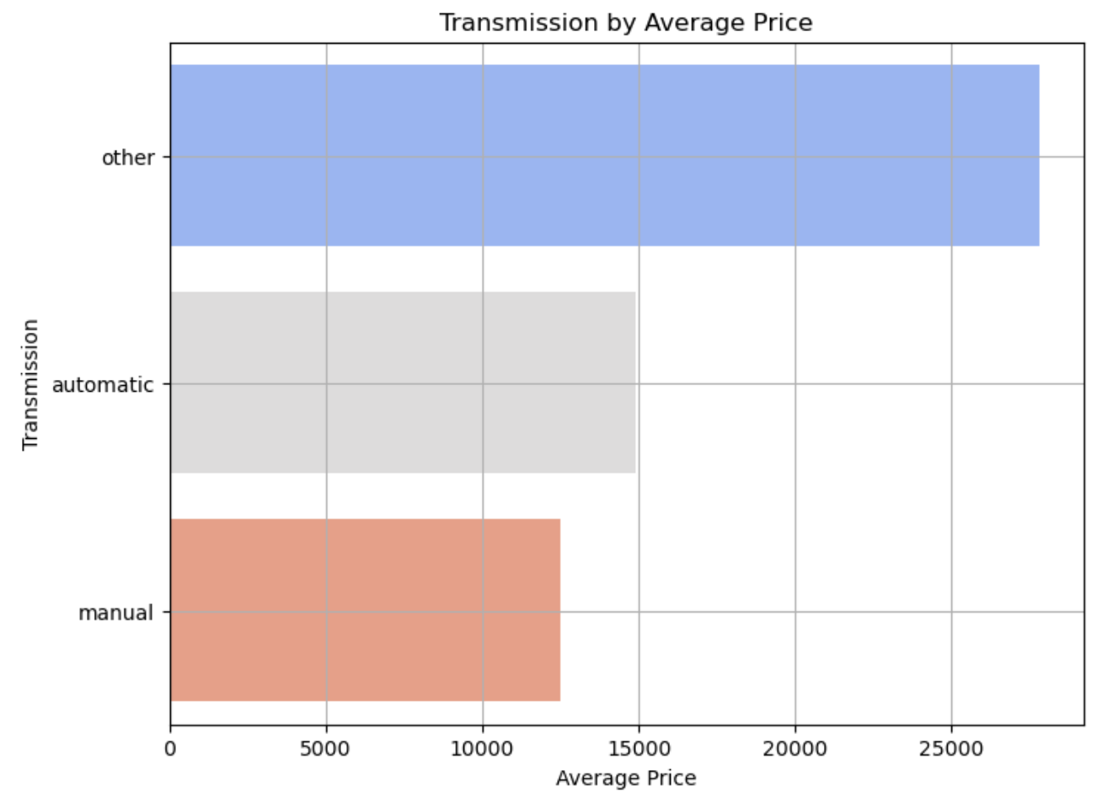

#### Fuel by Price:

* + **Diesel** and **electric** vehicles tend to be the most expensive, with higher price distributions.
  + **Gas** and **hybrid** vehicles dominate the lower price ranges.

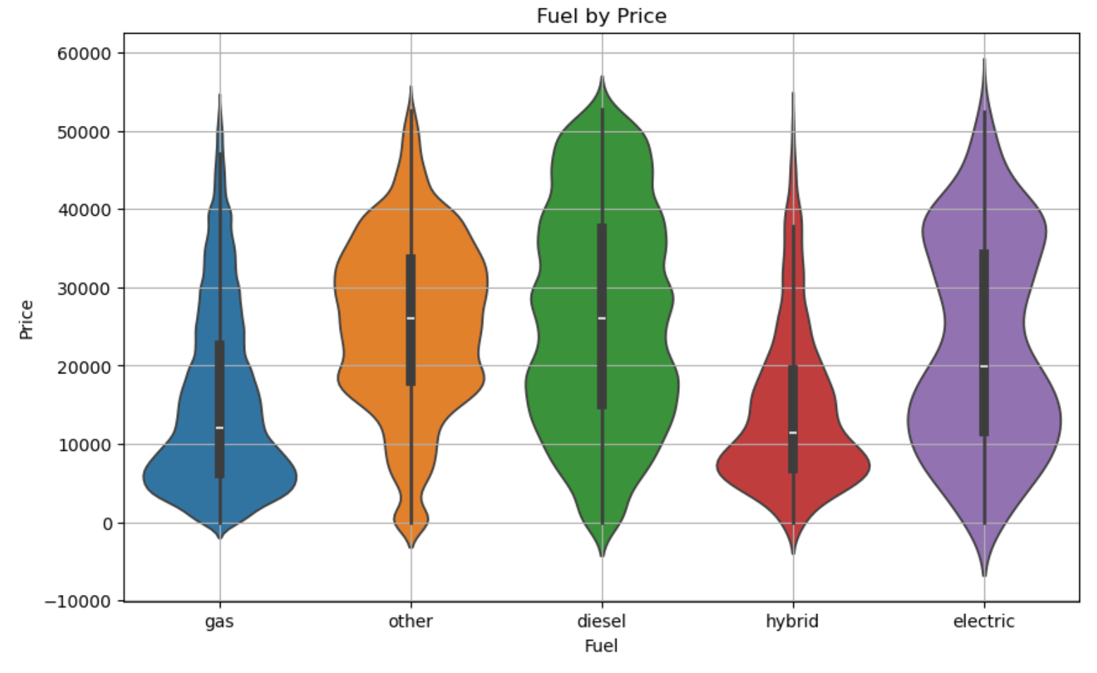

#### Drive by Price:

* + 4wd and rwd vehicles, tend to command higher prices, likely due to their association with premium or performance vehicles (rwd) and utility or off-road vehicles (4wd).
  + fwd vehicles dominate the lower price ranges.

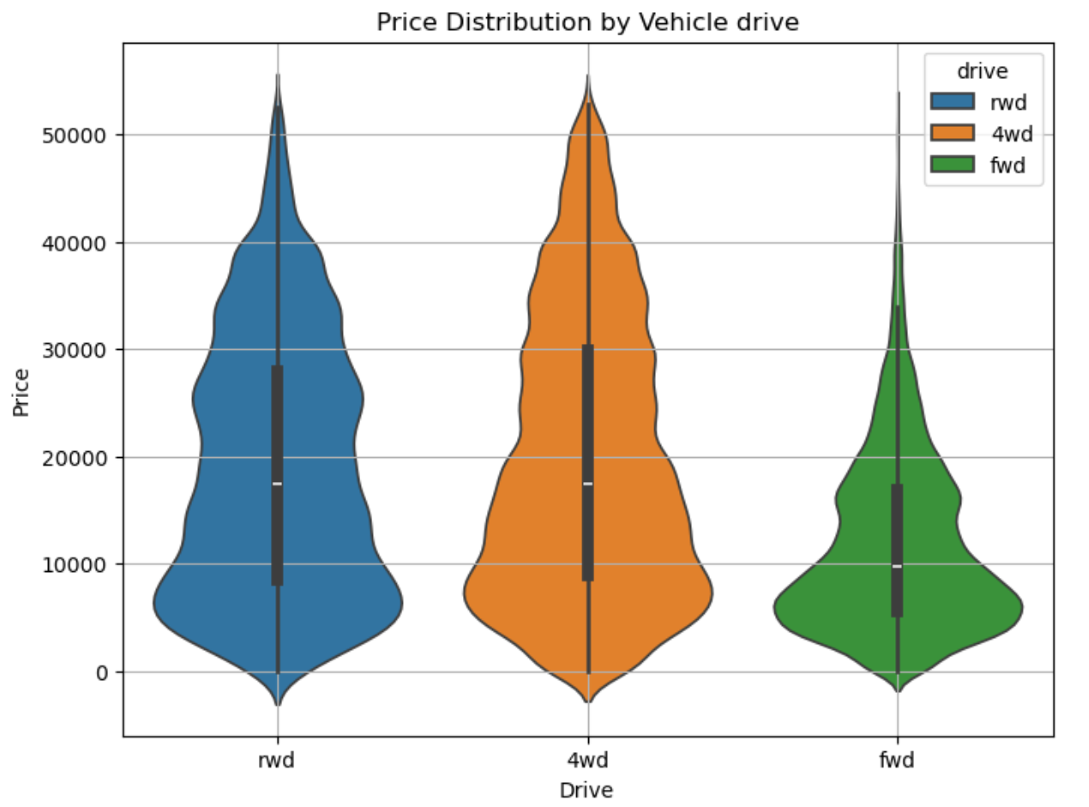

#### Size by Average Price:

* + **Full-size vehicles** dominate the higher price range, indicating their premium nature.
  + **Compact and mid-size vehicles** are more budget-friendly and likely cater to cost-conscious buyers.

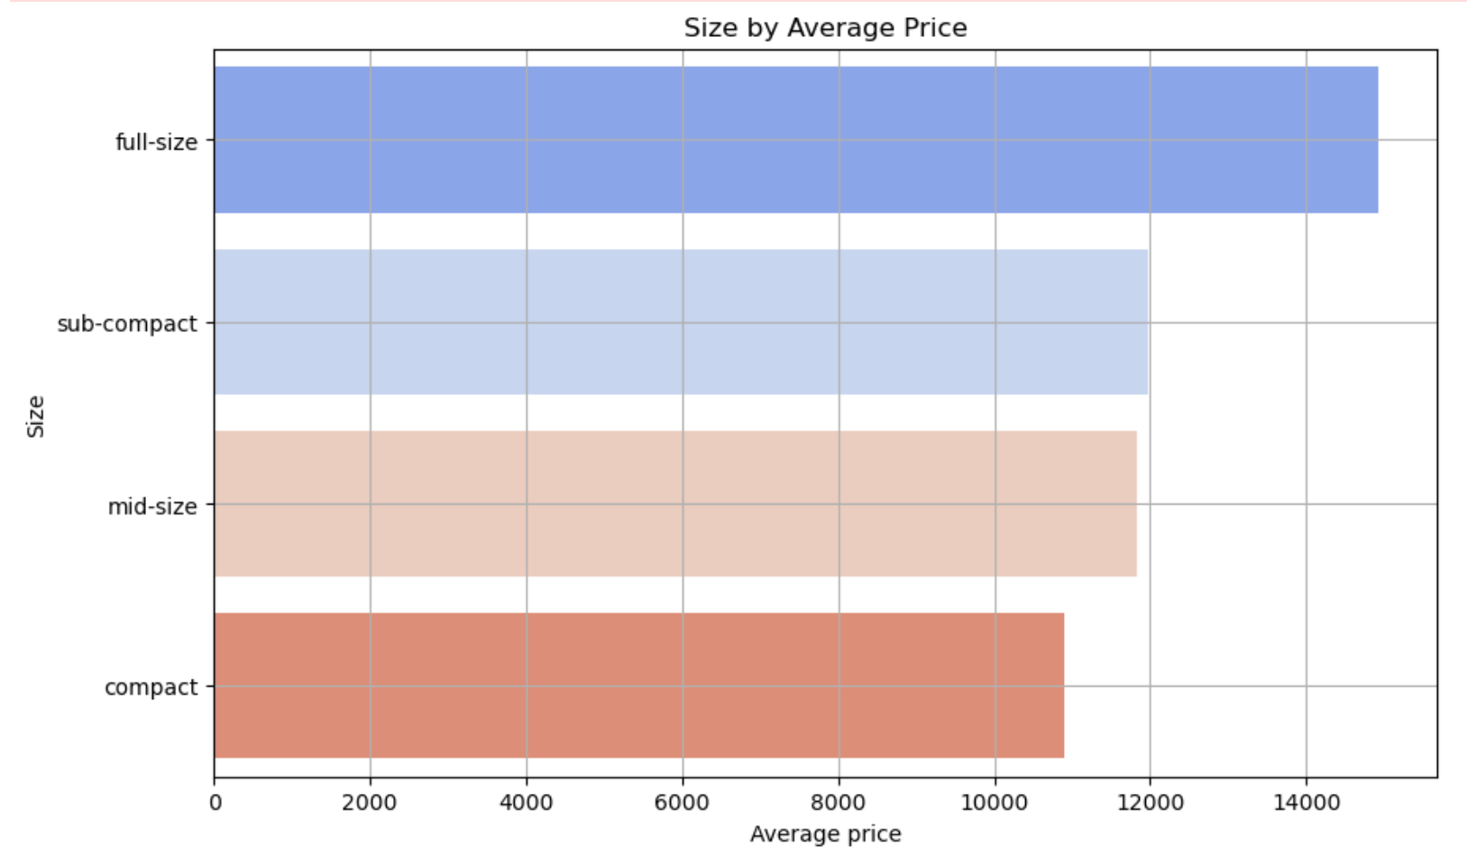

#### Car type by Average price

* + **Utility Vehicles** (e.g., pickup, truck, SUV, off-road): These vehicles dominate the higher price range, reflecting their durability and versatile use cases.
  + **Luxury Types** (e.g., coupe, convertible): Priced mid-high, catering to niche buyers.
  + **Budget-Friendly Types** (e.g., mini-van, sedan, wagon): Affordable, practical vehicles for cost-conscious buyers.

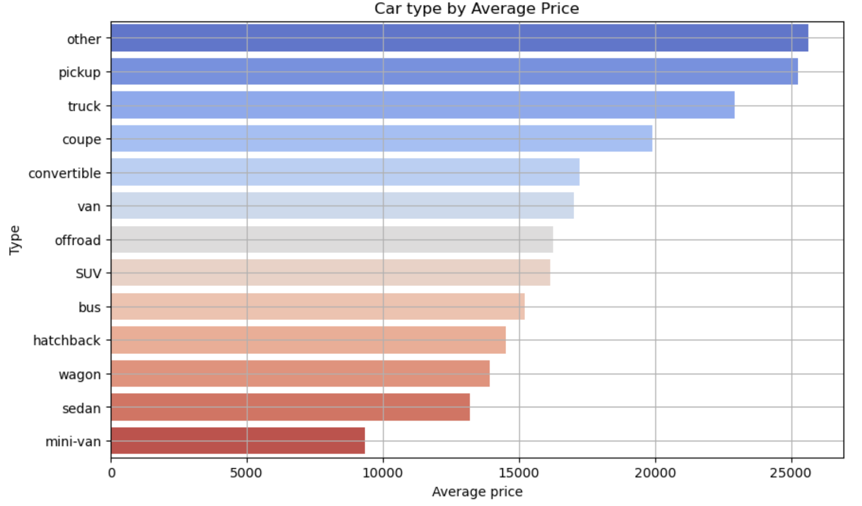

#### States by average price

* + Higher average prices are concentrated in **rural and western states** (e.g., West Virginia, Alaska, Wyoming).
  + Lower average prices are seen in **Midwestern and Northeastern states** (e.g., Iowa, Wisconsin, Connecticut

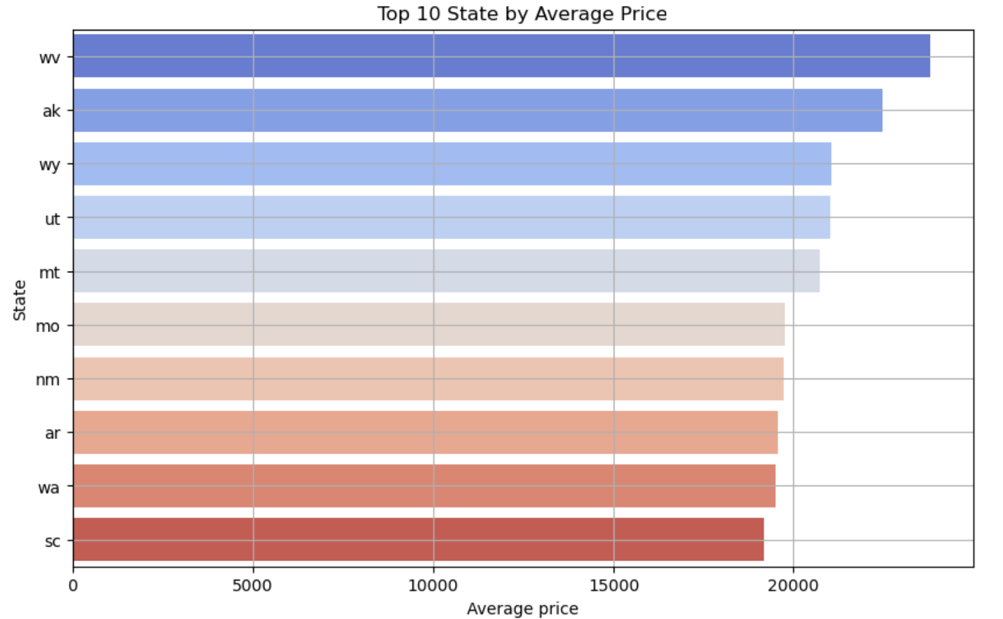

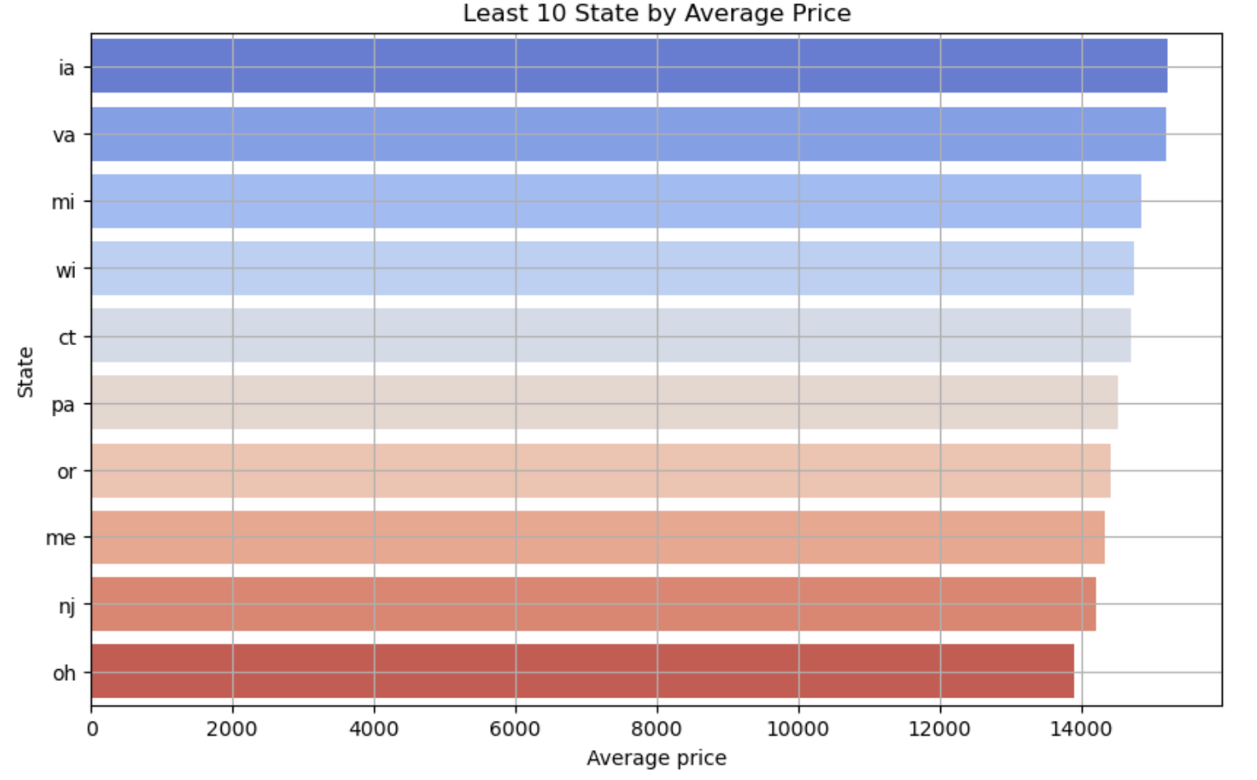

## Correlation matrix:

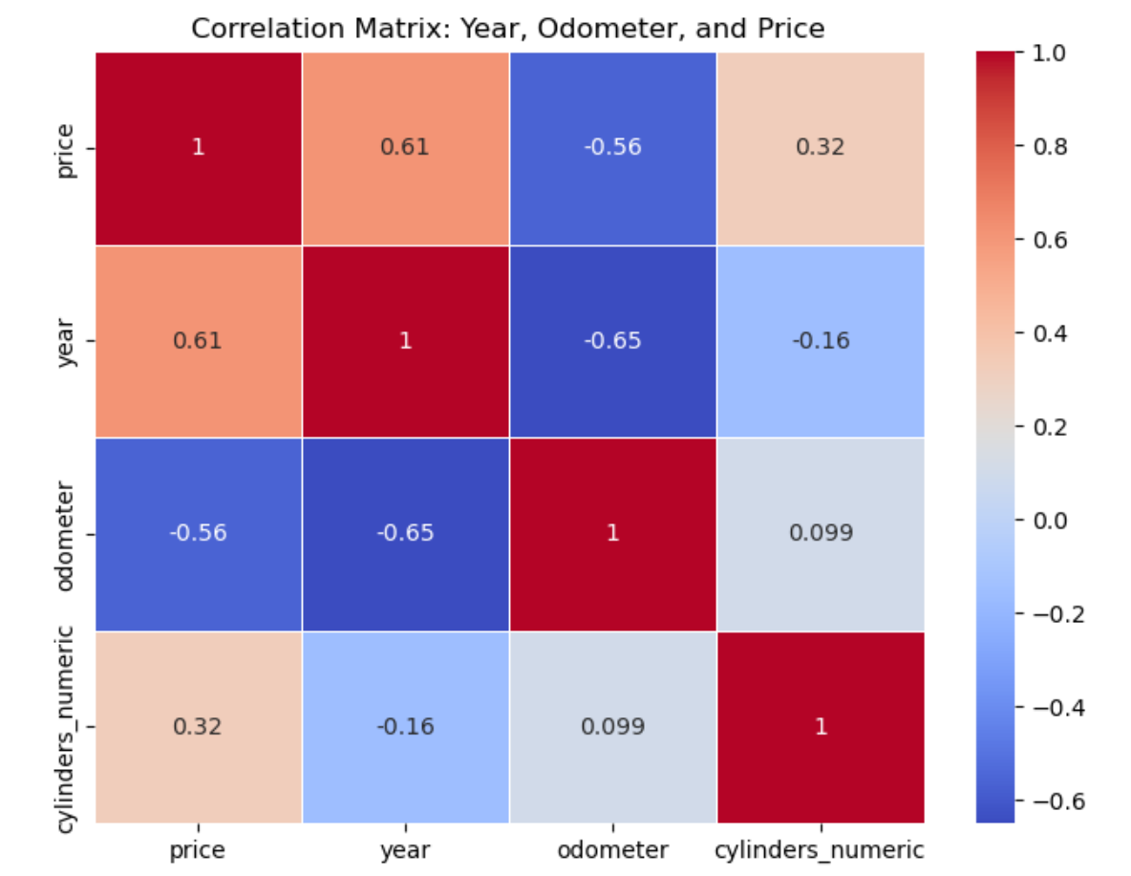

**Key Findings**

**Correlation Analysis**

* **Year** has a **positive correlation** (0.48) with **price**, indicating newer vehicles tend to have higher prices.
* **Odometer** has a **negative correlation** (-0.38) with **price**, suggesting vehicles with higher mileage are priced lower.

**Price predictions**

* 1. **Price Prediction based on only numerical features:** The model predicts **price** based on **year**, cylinders and **odometer**:

|  |  |  |  |
| --- | --- | --- | --- |
| **Model** | **RMSE** | **R² Score** | **Cross-Validation R²** |
| **Linear Regression** | 8313.18 | 0.53 | - |
| **Ridge Regression** | 8313.18 | 0.53 | 0.52 |
| **Lasso Regression** | 8313.18 | 0.53 | 0.52 |

|  |  |  |
| --- | --- | --- |
| **Linear Coefficients:** | **Ridge Coefficients:** | **Lasso Coefficients:** |
| year 968.27 | year 968.27 | year 968.26 |
| odometer -0.05 | odometer -0.05 | odometer -0.05 |
| cylinders_numeric 3127.92 | cylinders_numeric 3127.91 | cylinders_numeric 3127.85 |

* + **Coefficient for Year**: 968.27  
    *Each additional year increases the price by ~$968.*
  + **Coefficient for Odometer**: -0.05  
    *Each additional mile decreases the price by ~$0.05.*
  + **Coefficient for Cylinder**: 3127  
    *Each additional cylinder increases the price by ~$3127.*
    - **Mean Squared Error (MSE)**: 8313
    - Indicates the average squared prediction error.
  + **R² Score**: 0.53
    - The model explains 53% of the variance in price.

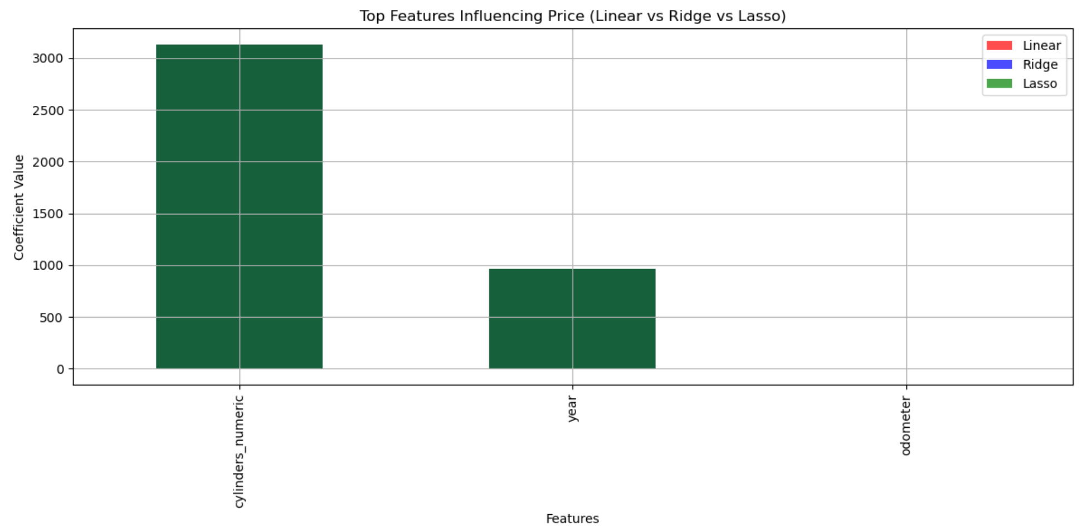

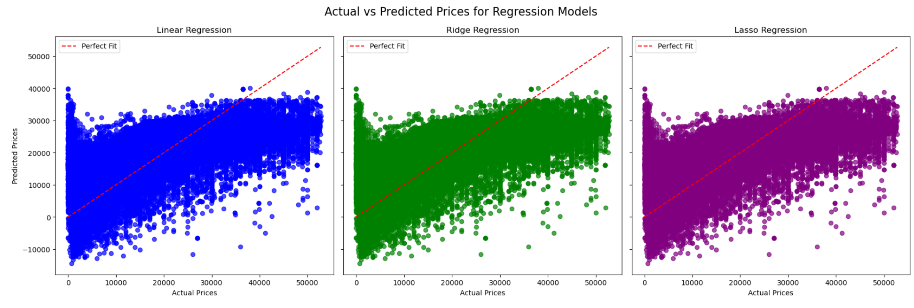

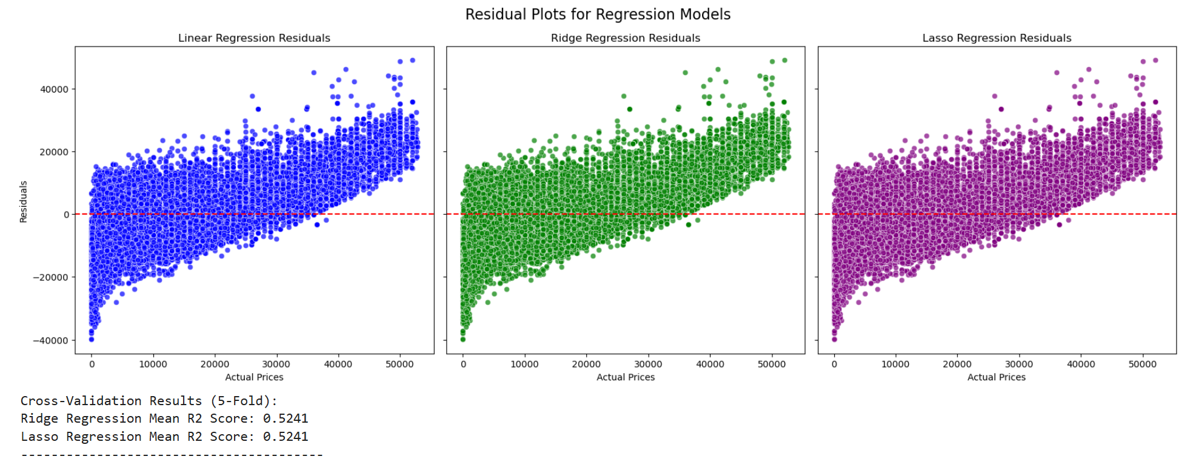

1. **Price Prediction based on only numerical and categorical features:** The model predicts **price** based on **year**, cylinders, **odometer, condition, transmission, fuel, title_status**

|  |  |  |  |
| --- | --- | --- | --- |
| **Model** | **RMSE** | **R² Score** | **Cross-Validation R²** |
| **Linear Regression** | 7332.7 | 0.62 | - |
| **Ridge Regression** | 7310.5 | 0.63 | 0.59 |
| **Lasso Regression** | 7560 | 0.60 | 0.59 |

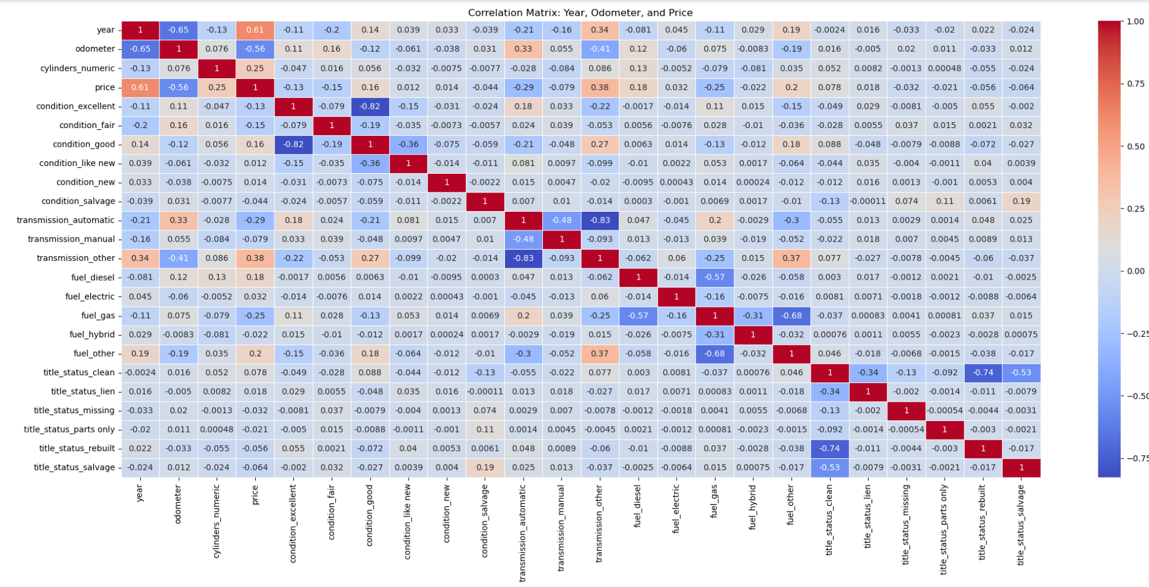

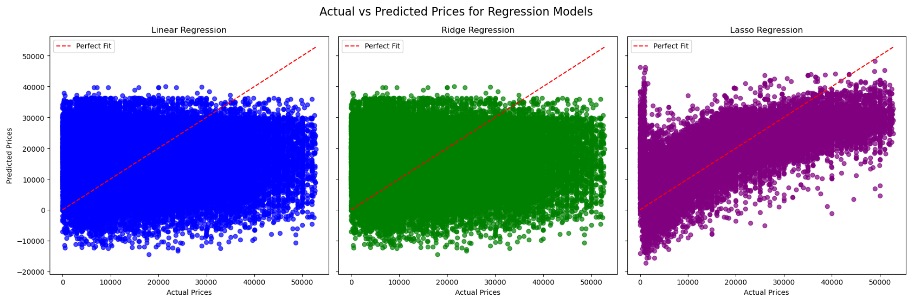

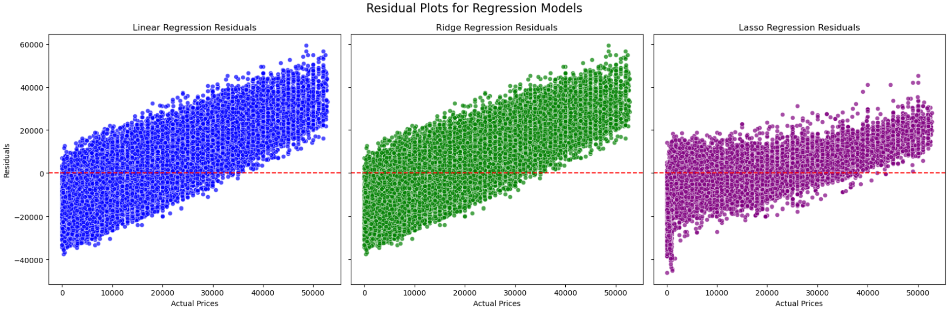

1. **Price Prediction based on only numeric ('year', 'odometer', 'cylinders_numeric') and categorical ('condition','transmission','fuel','title_status','drive','size', 'type', 'paint_color') features**

|  |  |  |
| --- | --- | --- |
| **Model** | **RMSE** | **R² Score** |
| **Linear Regression** | 8036.33 | 0.56 |
| **Ridge Regression** | 8036.34 | 0.56 |
| **Lasso Regression** | 8036.34 | 0.56 |

1. **Price prediction based on all columns - Ordinal encoding for 'manufacturer','model','state' columns**

|  |  |  |
| --- | --- | --- |
| **Model** | **RMSE** | **R² Score** |
| **Linear Regression** | 7560.03 | 0.64 |
| **Ridge Regression** | 7560.03 | 0.64 |
| **Lasso Regression** | 7560.03 | 0.64 |

**With polynomial degree=2**

|  |  |  |  |
| --- | --- | --- | --- |
| **Model** | **RMSE** | **R² Score** | **Cross-Validation R²** |
| **Linear Regression** | 6450.57 | 0.72 | - |
| **Ridge Regression** | 6448.94 | 0.72 | 0.70 |
| **Lasso Regression** | 6446.48 | 0.72 | 0.70 |

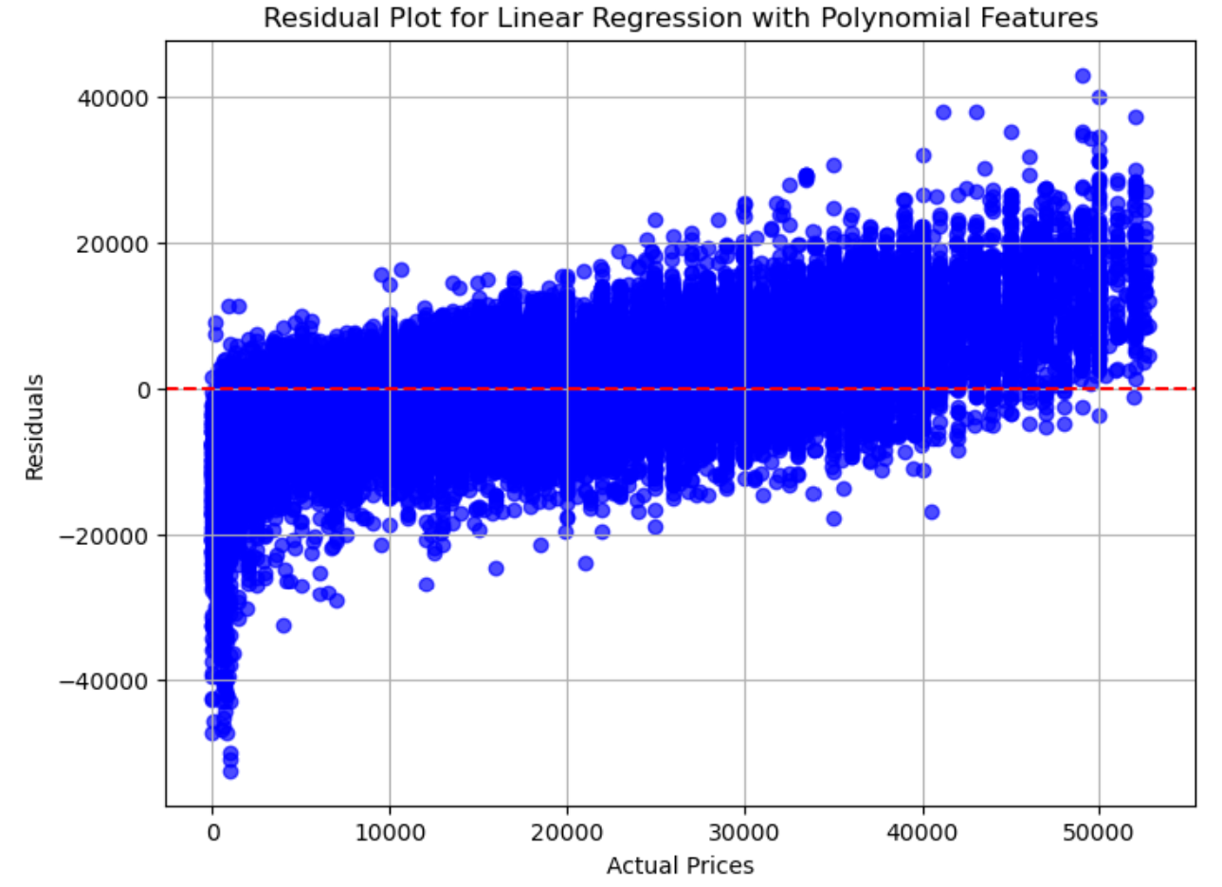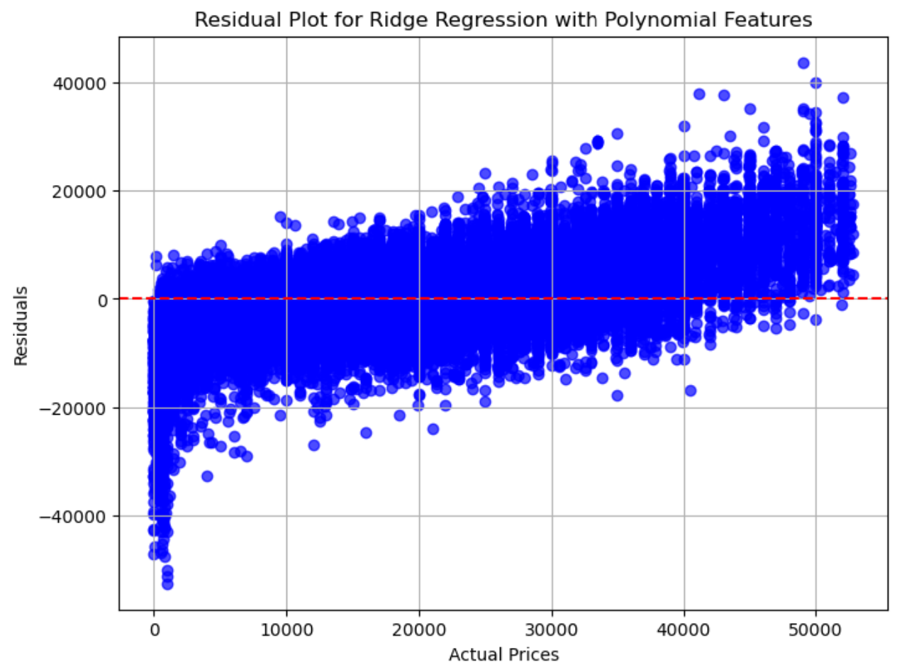

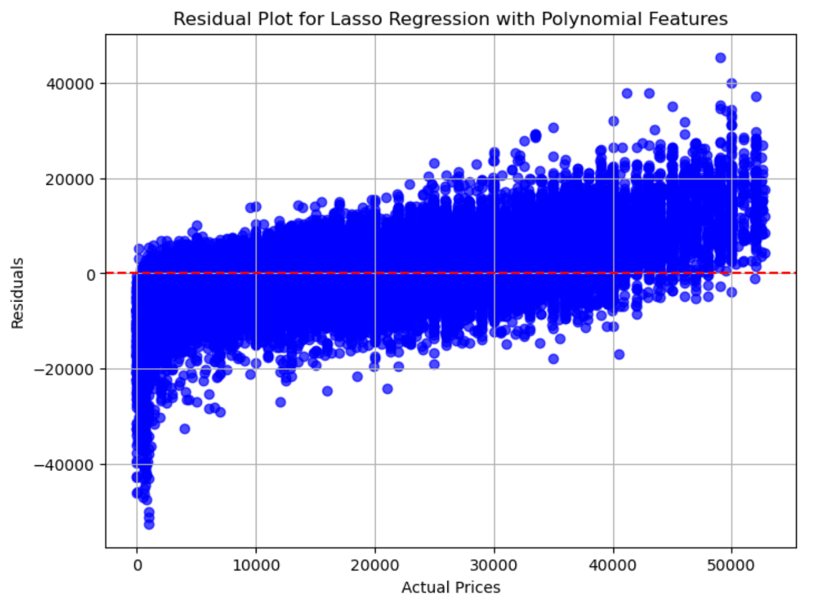

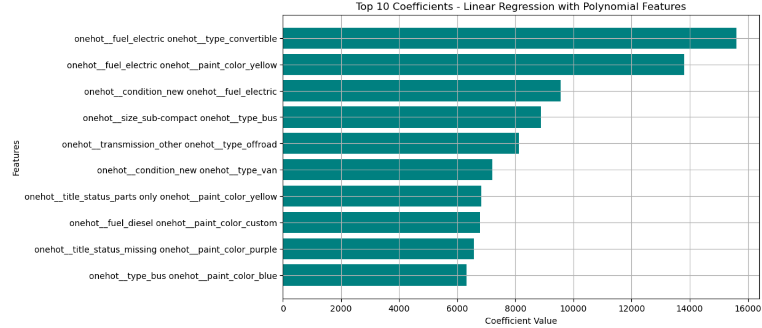

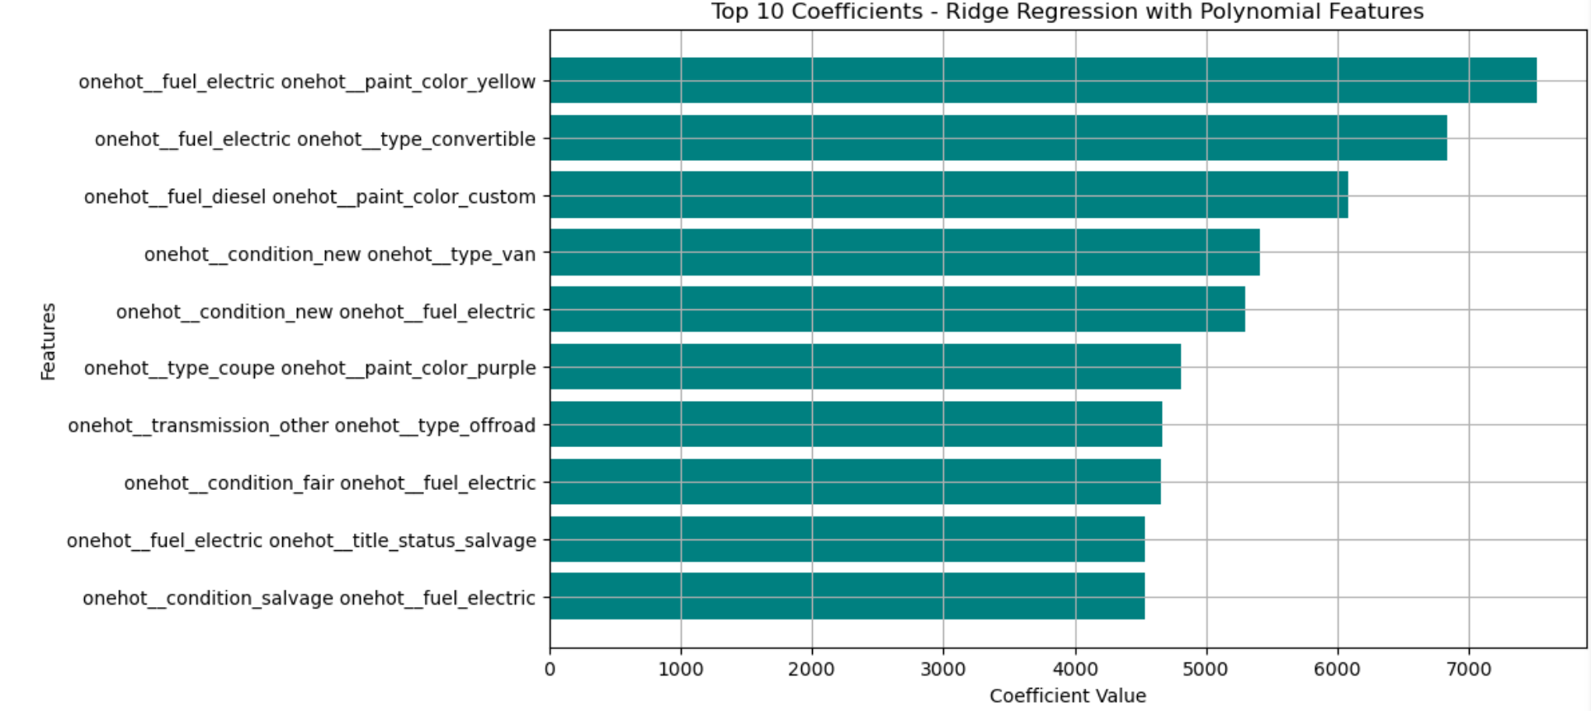

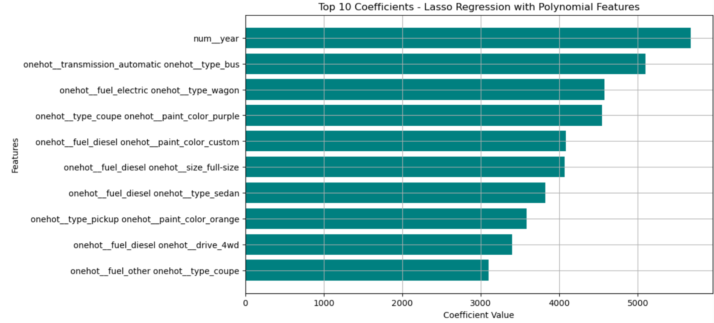

**Linear regression**

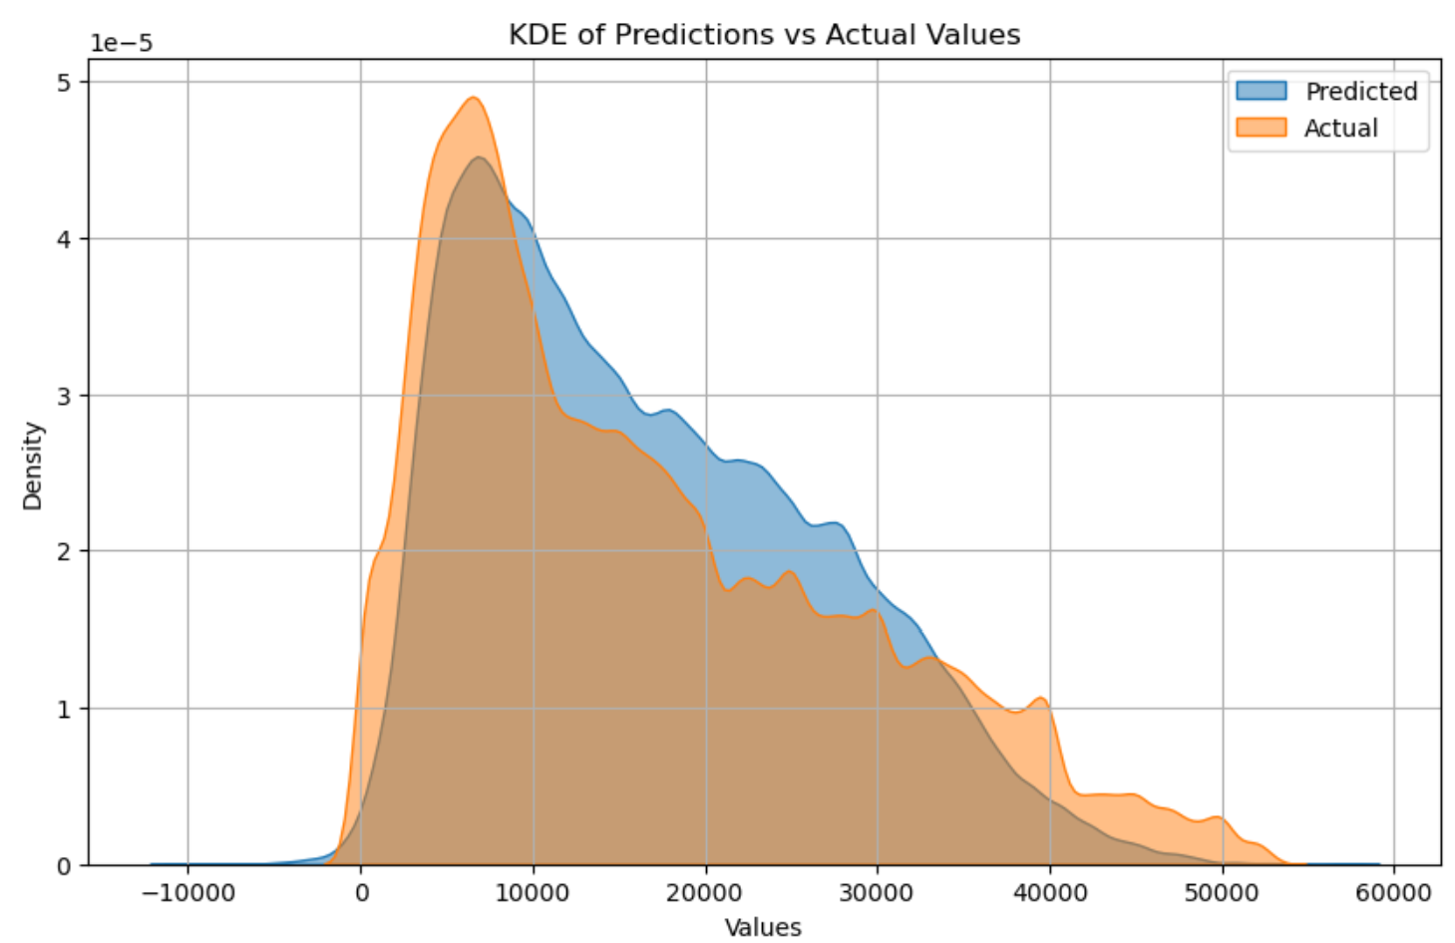

**Ridge regression**

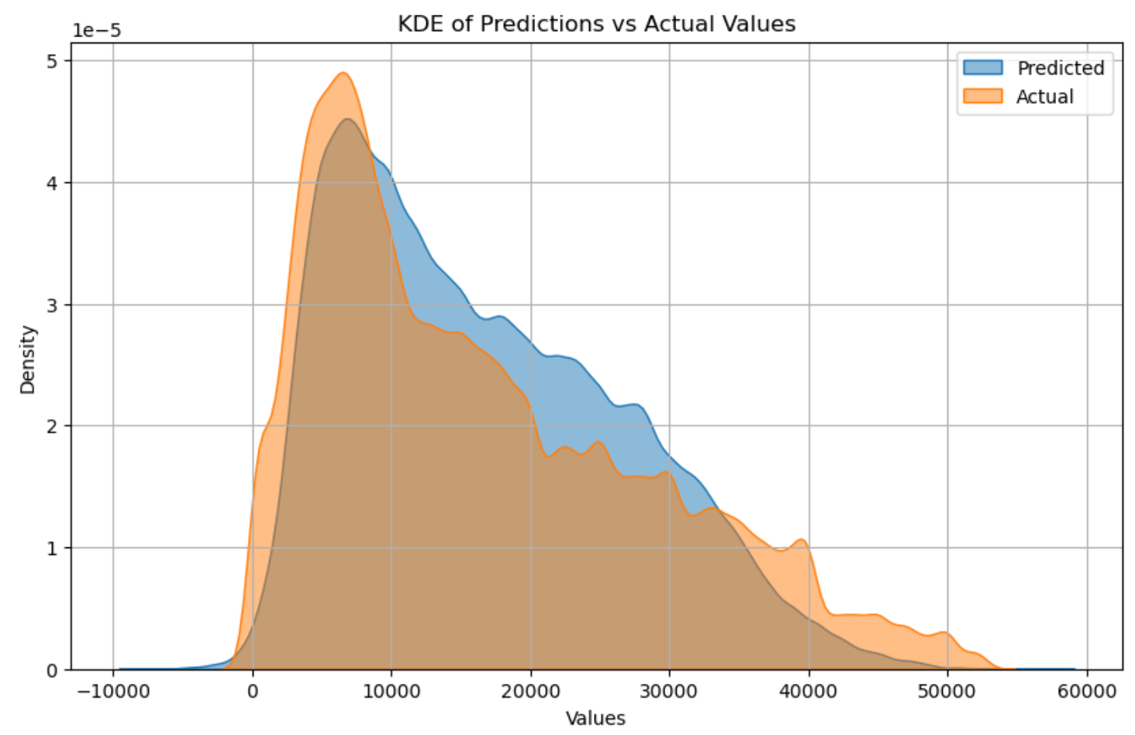

**Lasso regression**

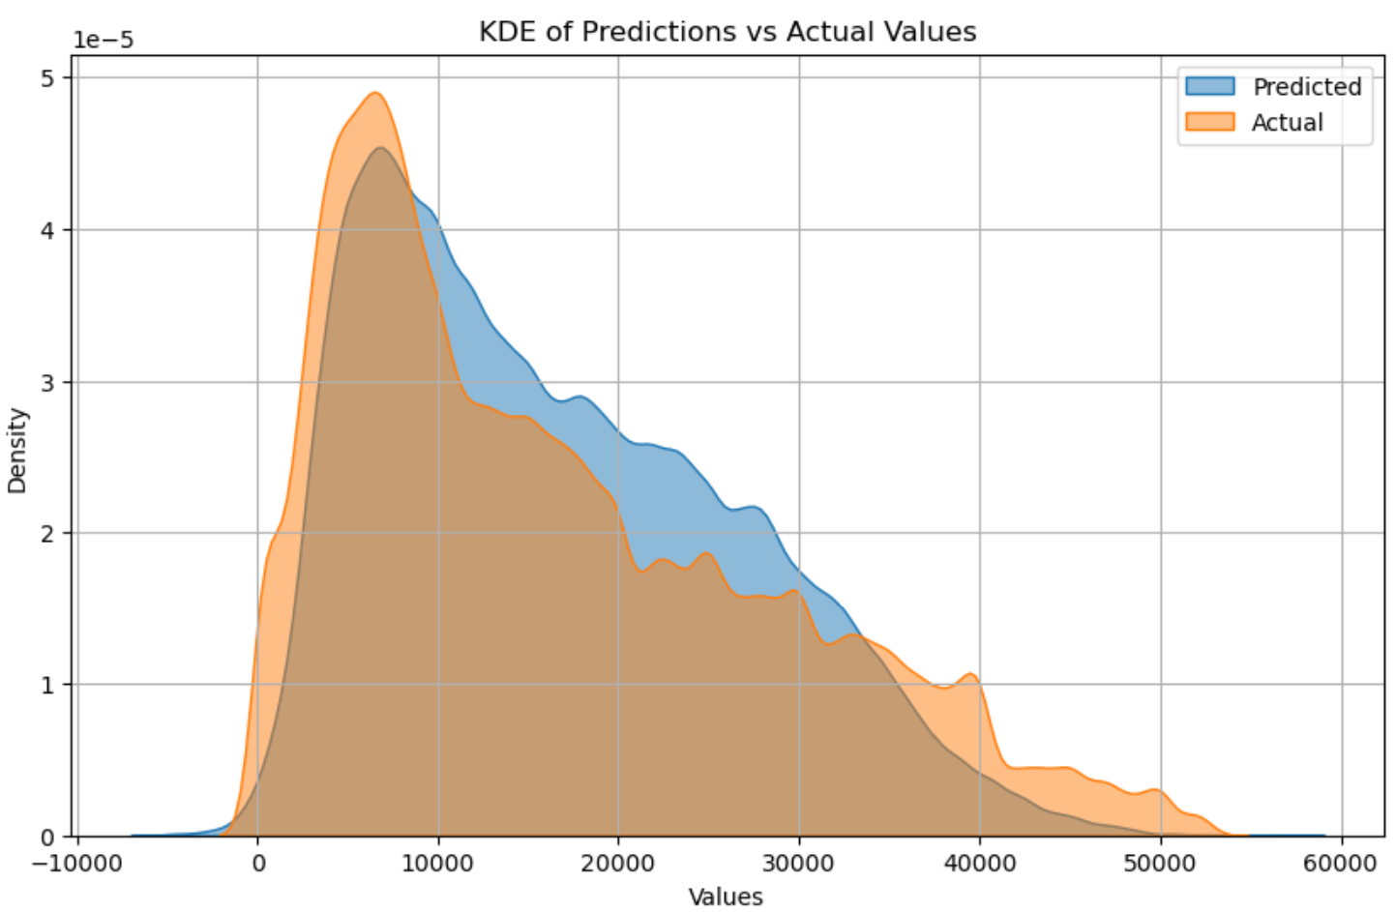

**With Cross-Validation and Optimal Alpha for Ridge and Lasso**

|  |  |  |  |
| --- | --- | --- | --- |
| **Model** | **RMSE** | **R² Score** | **Best Alpha** |
| **Ridge Regression** | 6461.58 | 0.71 | 100 |
| **Lasso Regression** | 6461 | 0.71 | 0.46 |

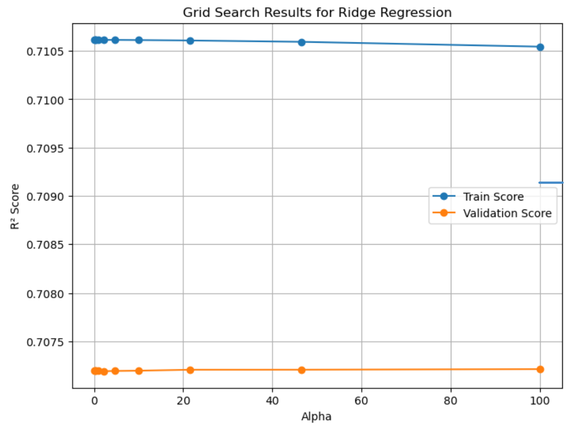

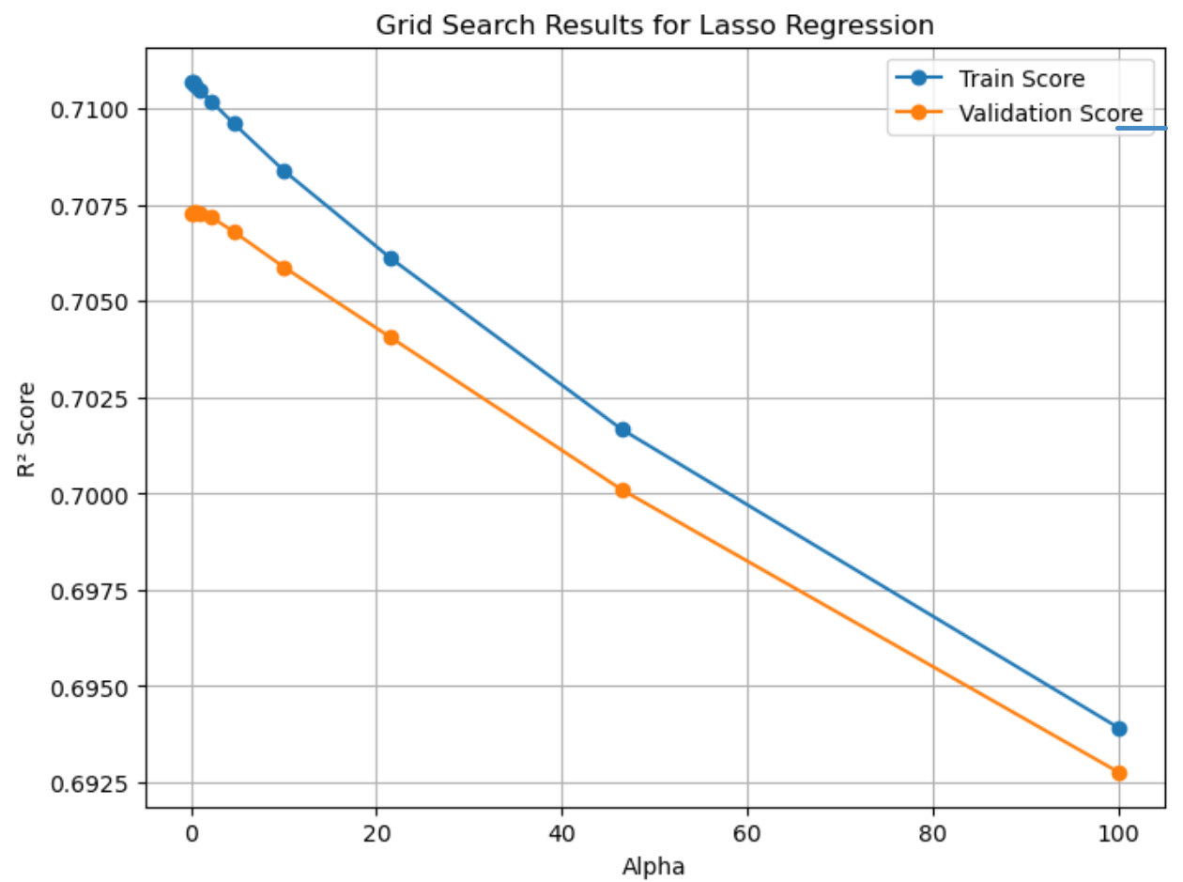

**\**

### Key Business Insights

#### Factors Influencing Car Prices:

* + **Year**: Newer cars (post-2015) have significantly higher prices. Each additional year increases the price by ~$968.
  + **Mileage (Odometer)**: Cars with lower mileage (<50,000 miles) command higher prices. Each additional mile decreases the price by ~$0.05.
  + **Cylinders**: Cars with higher cylinders (4, 6, and 8) are valued more. Each additional cylinder increases the price by ~$3,127.

#### Visual Findings:

* + **Paint Color**: Vehicles in black and white colors have higher prices, while green and purple are less desirable.
  + **Condition**: Vehicles in "new" and "good" condition dominate the higher price range.
  + **Fuel Type**: Diesel and electric vehicles are the most expensive, while gas and hybrids are more affordable.
  + **Drive Type**: 4WD and RWD vehicles command premium prices due to their utility and performance associations.
  + **Car Size**: Full-size vehicles are premium, while compact and mid-size vehicles cater to budget-conscious buyers.
  + **Car Type**: Trucks, SUVs, and pickups dominate the high price ranges. Sedans and mini-vans are more affordable.

#### State-Specific Insights:

* + **Higher Prices**: States like West Virginia, Alaska, and Wyoming have higher average prices.
  + **Lower Prices**: States like Iowa, Virginia, and Michigan feature lower-priced vehicles.

### Model Comparison for Price Prediction

#### Using Only Numerical Features

Features: year, odometer, cylinders

|  |  |  |  |
| --- | --- | --- | --- |
| **Model** | **RMSE** | **R² Score** | **Cross-Validation R²** |
| **Linear Regression** | 8313.18 | 0.53 | - |
| **Ridge Regression** | 8313.18 | 0.53 | 0.52 |
| **Lasso Regression** | 8313.18 | 0.53 | 0.52 |

Insights:

* Numerical features alone explain 53% of the variance in car prices, but the error (RMSE: 8313) is relatively high. Models perform equally.

#### Adding Categorical Features

Features: Numerical + condition, transmission, fuel, title_status

|  |  |  |  |
| --- | --- | --- | --- |
| **Model** | **RMSE** | **R² Score** | **Cross-Validation R²** |
| **Linear Regression** | 7332.7 | 0.62 | - |
| **Ridge Regression** | 7310.5 | 0.63 | 0.59 |
| **Lasso Regression** | 7560 | 0.60 | 0.59 |

Insights:

* Adding categorical features improves the R² Score to 0.63 and reduces the RMSE to 7310. Ridge regression performs slightly better than Lasso.

#### Full Feature Set with Ordinal Encoding

|  |  |  |
| --- | --- | --- |
| **Model** | **RMSE** | **R² Score** |
| **Linear Regression** | 7560.03 | 0.64 |
| **Ridge Regression** | 7560.03 | 0.64 |
| **Lasso Regression** | 7560.03 | 0.64 |

Features: All numerical and categorical features (manufacturer, model, state)

Insights:

* The inclusion of additional categorical features slightly improves performance but does not drastically change results.

#### Polynomial Features (Degree = 2)

Features: All numerical and categorical features with polynomial expansion

|  |  |  |  |
| --- | --- | --- | --- |
| **Model** | **RMSE** | **R² Score** | **Cross-Validation R²** |
| **Linear Regression** | 6450.57 | 0.72 | - |
| **Ridge Regression** | 6448.94 | 0.72 | 0.70 |
| **Lasso Regression** | 6446.48 | 0.72 | 0.70 |

Insights:

* Polynomial features significantly improve model performance. The R² score reaches 0.72, and the RMSE reduces to ~6446. Lasso regression slightly outperforms Ridge and Linear Regression.

#### Cross-Validation with Optimal Alpha

|  |  |  |  |
| --- | --- | --- | --- |
| **Model** | **RMSE** | **R² Score** | **Best Alpha** |
| **Ridge Regression** | 6461.58 | 0.71 | 100 |
| **Lasso Regression** | 6461 | 0.71 | 0.46 |

Insights:

* Fine-tuning hyperparameters using cross-validation provides optimal results. Ridge and Lasso regressions both achieve an R² of 0.71 with similar RMSE values (~6461).

### Summary of Model Performance

|  |  |  |  |
| --- | --- | --- | --- |
| Model | Best R² | Lowest RMSE | Best Configuration |
| Linear Regression | 0.72 | 6450.57 | Polynomial Features (Degree = 2) |
| Ridge Regression | 0.72 | 6448.94 | Polynomial + Alpha Tuning (100) |
| Lasso Regression | 0.72 | 6446.48 | Polynomial + Alpha Tuning (0.46) |

### Summary of Key Business Actions

#### Segment Inventory:

* + Stock premium vehicles (e.g., electric, luxury, full-size) for high-demand regions and demographics.
  + Prioritize affordable vehicles (e.g., compact, gas-powered) for budget-focused buyers.

#### Location-Based Strategy:

* + Focus high-end inventory in regions like West Virginia, Alaska, and Wyoming.
  + Promote affordable cars in Iowa, Wisconsin, and Connecticut.

#### Market Differentiation:

* + Highlight features like low mileage, popular colors (white, black), and high-demand fuel types (diesel, electric).
  + Use targeted promotions for vehicles with manual transmissions or less popular colors.

#### Focus on Vehicle Condition:

* + Emphasize "new" and "good" condition vehicles to maximize margins.
  + Leverage lower-condition vehicles for bargain hunters and niche markets.

#### Leverage Trends:

* + Market SUVs, pickups, and full-size vehicles to customers in rural or high-demand markets.
  + Use luxury and niche vehicles (e.g., coupes, convertibles) to cater to specific buyer preferences.